BATHROOM GALLERY

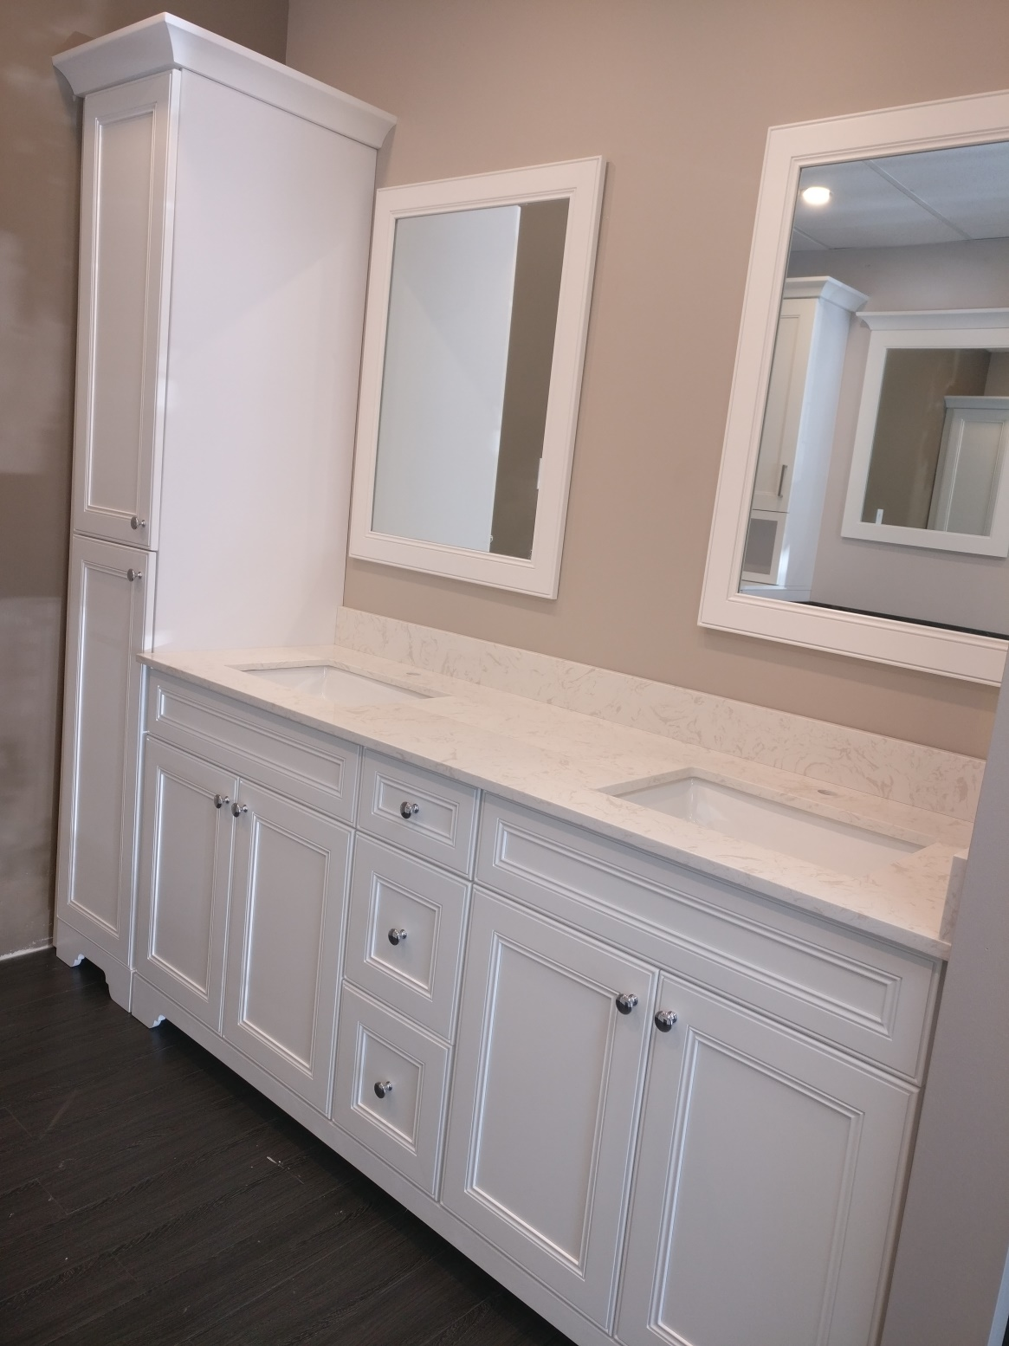

**Cabinets Express Canada Cabinetry:**

Frameless or framed , ready-to-assemble (RTA), in stock

Interior and exterior finishes match

Solid maple cabinet doors, drawer fronts and drawers for stained cabinets

¾" plywood boxes and shelves

Lifetime warranty soft close adjustable hinges for all standard cabinets

Drawers feature dovetail construction

Drawers have full extension, under mount soft-close glides

Extra layer decorative furniture toe-kick

Superior quality, unbeatable prices for all budgets

**9 Standard Colors Available at Cabinets Express Canada:**

|  |  |
| --- | --- |
| **Bevelled Shaker**  Dove White.jpg | **Color: Dove White**  **Material: All HDF** |
| **Shaker**  White Shaker.jpg | **Color: White Shaker**  **Material: All HDF** |
| **Stepped Shaker**  Step Shaker White  Kitchen and Bath.jpg | **Color: Stepped White Shaker**  **Material: All HDF** |
| **Stepped Shaker**  Step Charcoal Grey Kitchen & Bath.jpg | **Color: Step Charcoal Grey**  **Material: Solid Wood** |

|  |  |
| --- | --- |
| **Stepped Shaker**  Step grey shaker.jpg | **Color: Step Grey**  **Material: Solid Wood** |
| **Shaker**  Espresso.jpg | **Color: Expresso**  **Material: Solid Wood** |
| **Raised Panel**  Walnut.jpg | **Color: Walnut Glaze**  **Material: Solid Wood** |
| **Raised Panel**  Antique White.jpg | **Color: Antique White**  **Material: Solid Wood** |
| **Bevelled Shaker**  Mocha.jpg | **Color: Mocha Glaze**  **Material: Solid Wood** |

|  |  |  |  |  |  |  |  |  |  |  |  |
| --- | --- | --- | --- | --- | --- | --- | --- | --- | --- | --- | --- |
| |  | | --- | |  | |  |  |  | |  |  | | | |  |
| Vanity Layouts and Dimensions (continues next page) |  |  |  | |  |  |  |  |  |  |
|  |  |  |  |  | |  |  |  |  |  |
|  |  |  |  |  |  |  |  |  |  |  |
| Vanity Layouts and Dimensions |  |  |  |  |  |  |  |  |  |  |
|  |  |  |  |  |  |  |  |  |  |  |
|  |  |  |  |  |  |  |  |  |  |  |
|  |  |  |  |  |  |  |  |  |  |  |
|  |  | |  |  | | |  | |  | |
|  |  |  |  |  |  |  |  |  |  |  |
|  |  |  |  |  |  |  |  |  |  |  |
|  |  |  |  | |  |  | |  |  |  |
|  |  |  |  |  | |  |  |  |  |  |
|  |  |  |  |  |  |  |  |  |  |  |
|  |  |  |  |  |  |  |  |  |  |  |
| INSPIRATION BATHROOM GALLERY  Stepped Shaker Step Grey Bathroom  Step Grey Vanity and Tower.jpg  Bevelled Shaker Dove White Bathroom |  |  |  |  |  |  |  |  |  |  |
|  |  |  |  |  |  |  |  |  |  |  |

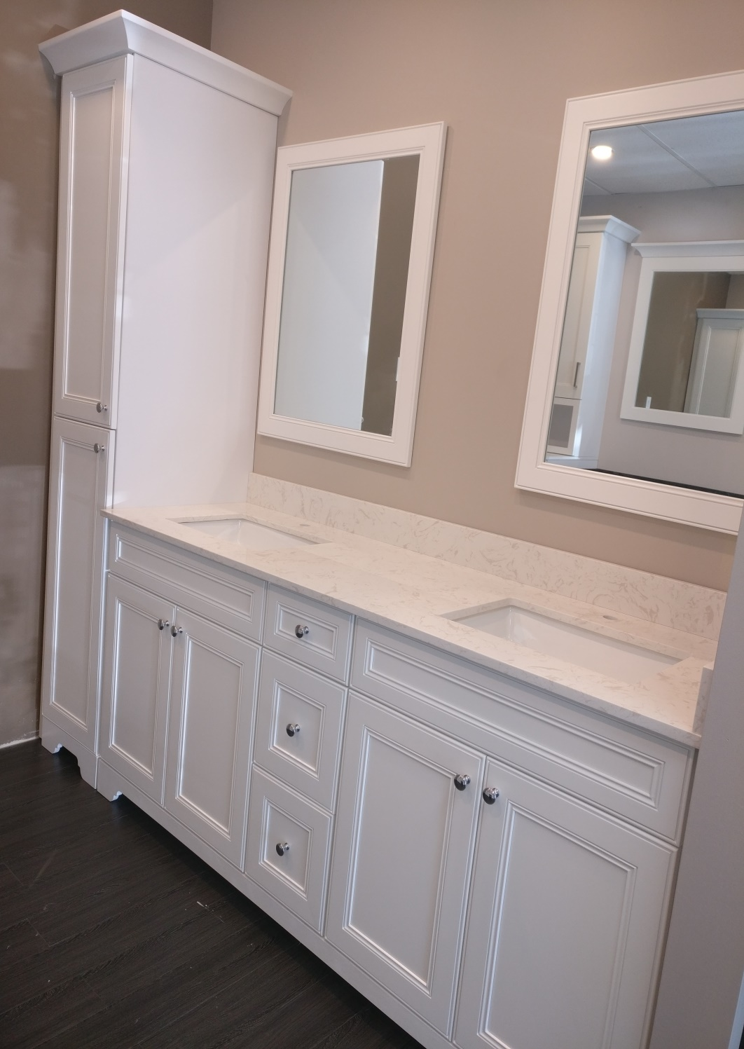

White Shaker Bathroom

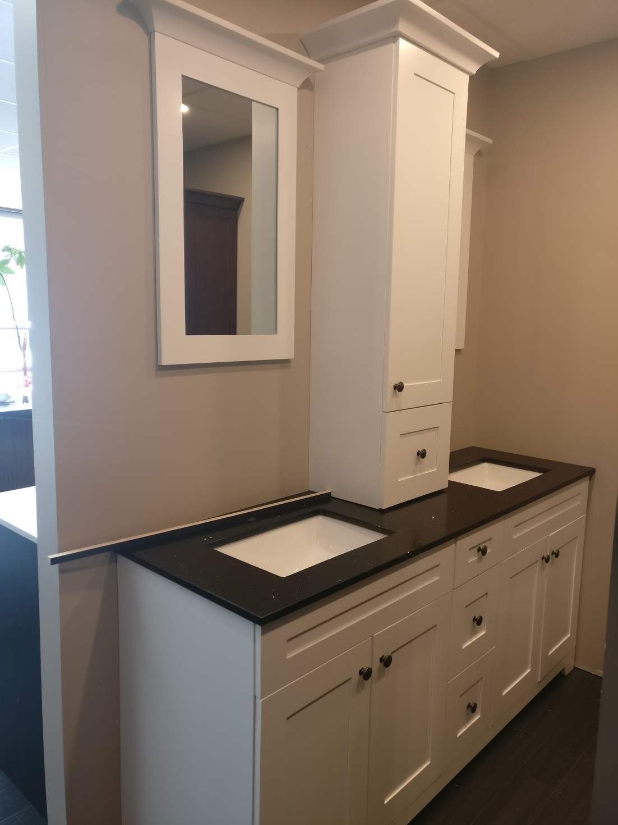

Bevelled Shaker Mocha Glaze Bathroom

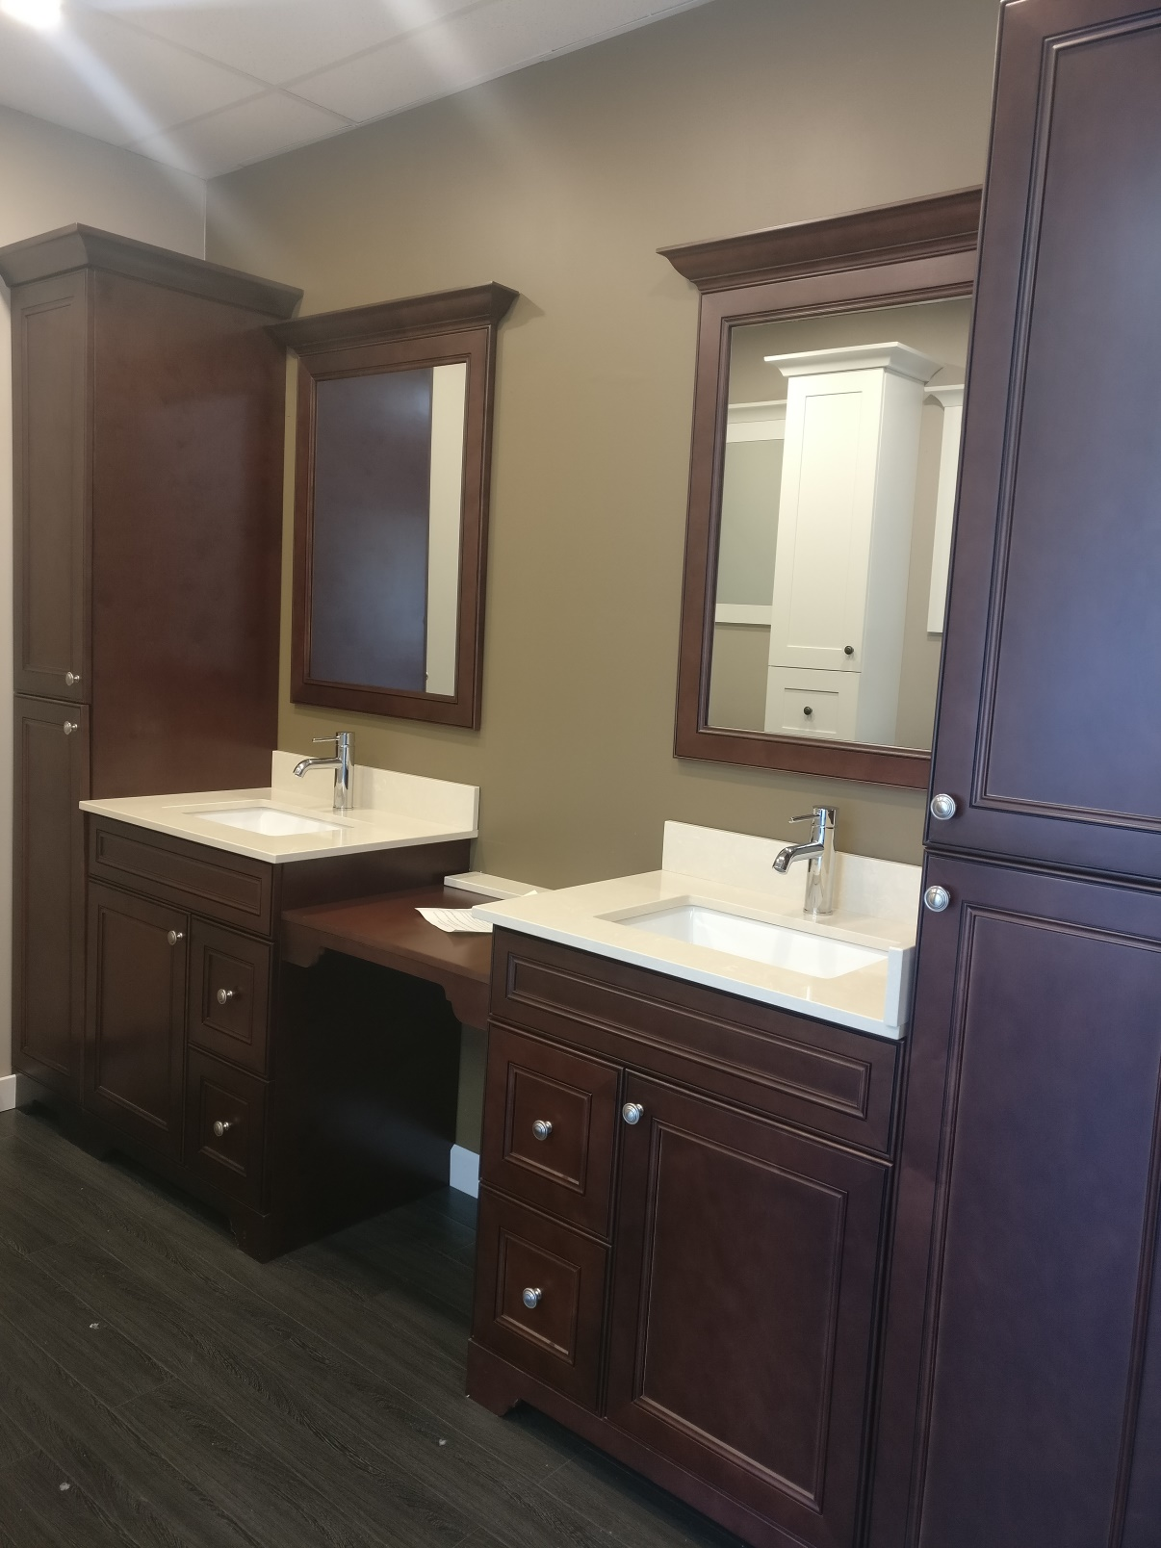

|  |  |  |  |  |  |  |  |  |  |  |  |  |  |  |  |  |  |  |  |  |  |  |  |  |  |  |  |  |  |  |  |  |  |  |  |  |  |  |  |  |  |  |  |  |  |  |  |  |  |  |  |  |  |  |  |  |  |  |  |  |  |  |  |  |  |  |  |  |  |  |  |  |  |  |  |  |  |  |  |  |  |  |  |  |  |  |  |  |  |  |  |  |  |  |  |  |  |  |  |  |  |  |  |  |  |  |  |  |  |  |  |  |  |  |  |  |  |  |  |  |  |  |  |  |  |  |  |  |  |  |  |  |  |  |  |  |  |  |  |  |  |  |  |  |  |  |  |  |  |  |  |  |  |  |  |  |  |  |  |  |  |  |  |  |  |  |  |  |  |  |  |  |  |  |  |  |  |  |  |  |  |  |  |  |  |  |  |  |  |  |  |  |  |  |  |  |  |  |  |  |  |  |  |  |  |  |  |  |  |  |  |  |  |  |  |  |  |  |  |  |  |  |  |  |  |  |  |  |  |  |  |  |  |  |  |  |  |  |  |  |  |  |  |  |  |  |  |  |  |  |  |  |  |  |  |  |  |  |  |  |  |  |  |  |  |  |  |  |  |  |  |  |  |  |  |  |  |  |  |  |  |  |  |  |  |  |  |  |  |  |  |  |  |  |  |  |  |  |  |  |  |  |  |  |  |  |  |  |  |  |  |  |  |  |  |  |  |  |  |  |  |  |  |  |  |  |  |  |  |  |  |  |  |  |  |  |  |  |  |  |  |  |  |  |  |  |  |  |  |  |  |  |  |  |  |  |  |  |  |  |  |  |  |  |  |  |  |  |  |  |  |  |  |  |  |  |  |  |  |  |  |  |  |  |  |  |  |  |  |  |  |  |  |  |  |  |  |  |  |  |  |  |  |  |  |  |  |  |  |  |  |  |  |  |  |  |  |  |  |  |  |  |  |  |  |  |  |  |  |  |  |  |  |  |  |  |  |  |  |  |  |  |  |  |  |  |  |  |  |  |  |  |  |  |  |  |  |  |  |  |  |  |  |  |  |  |  |  |  |  |  |  |  |  |  |  |  |  |  |  |  |  |  |  |  |  |  |  |  |  |  |  |  |  |  |  |  |  |  |  |  |  |  |  |  |  |  |  |  |  |  |  |  |  |  |  |  |  |  |  |  |  |  |  |  |  |  |  |  |  |  |  |  |  |  |  |  |  |  |  |  |  |  |  |  |  |  |  |  |  |  |  |  |  |  |  |  |  |  |  |  |  |  |  |  |  |  |  |  |  |  |  |  |  |  |  |  |  |  |  |  |  |  |  |  |  |  |  |  |  |  |  |  |
| --- | --- | --- | --- | --- | --- | --- | --- | --- | --- | --- | --- | --- | --- | --- | --- | --- | --- | --- | --- | --- | --- | --- | --- | --- | --- | --- | --- | --- | --- | --- | --- | --- | --- | --- | --- | --- | --- | --- | --- | --- | --- | --- | --- | --- | --- | --- | --- | --- | --- | --- | --- | --- | --- | --- | --- | --- | --- | --- | --- | --- | --- | --- | --- | --- | --- | --- | --- | --- | --- | --- | --- | --- | --- | --- | --- | --- | --- | --- | --- | --- | --- | --- | --- | --- | --- | --- | --- | --- | --- | --- | --- | --- | --- | --- | --- | --- | --- | --- | --- | --- | --- | --- | --- | --- | --- | --- | --- | --- | --- | --- | --- | --- | --- | --- | --- | --- | --- | --- | --- | --- | --- | --- | --- | --- | --- | --- | --- | --- | --- | --- | --- | --- | --- | --- | --- | --- | --- | --- | --- | --- | --- | --- | --- | --- | --- | --- | --- | --- | --- | --- | --- | --- | --- | --- | --- | --- | --- | --- | --- | --- | --- | --- | --- | --- | --- | --- | --- | --- | --- | --- | --- | --- | --- | --- | --- | --- | --- | --- | --- | --- | --- | --- | --- | --- | --- | --- | --- | --- | --- | --- | --- | --- | --- | --- | --- | --- | --- | --- | --- | --- | --- | --- | --- | --- | --- | --- | --- | --- | --- | --- | --- | --- | --- | --- | --- | --- | --- | --- | --- | --- | --- | --- | --- | --- | --- | --- | --- | --- | --- | --- | --- | --- | --- | --- | --- | --- | --- | --- | --- | --- | --- | --- | --- | --- | --- | --- | --- | --- | --- | --- | --- | --- | --- | --- | --- | --- | --- | --- | --- | --- | --- | --- | --- | --- | --- | --- | --- | --- | --- | --- | --- | --- | --- | --- | --- | --- | --- | --- | --- | --- | --- | --- | --- | --- | --- | --- | --- | --- | --- | --- | --- | --- | --- | --- | --- | --- | --- | --- | --- | --- | --- | --- | --- | --- | --- | --- | --- | --- | --- | --- | --- | --- | --- | --- | --- | --- | --- | --- | --- | --- | --- | --- | --- | --- | --- | --- | --- | --- | --- | --- | --- | --- | --- | --- | --- | --- | --- | --- | --- | --- | --- | --- | --- | --- | --- | --- | --- | --- | --- | --- | --- | --- | --- | --- | --- | --- | --- | --- | --- | --- | --- | --- | --- | --- | --- | --- | --- | --- | --- | --- | --- | --- | --- | --- | --- | --- | --- | --- | --- | --- | --- | --- | --- | --- | --- | --- | --- | --- | --- | --- | --- | --- | --- | --- | --- | --- | --- | --- | --- | --- | --- | --- | --- | --- | --- | --- | --- | --- | --- | --- | --- | --- | --- | --- | --- | --- | --- | --- | --- | --- | --- | --- | --- | --- | --- | --- | --- | --- | --- | --- | --- | --- | --- | --- | --- | --- | --- | --- | --- | --- | --- | --- | --- | --- | --- | --- | --- | --- | --- | --- | --- | --- | --- | --- | --- | --- | --- | --- | --- | --- | --- | --- | --- | --- | --- | --- | --- | --- | --- | --- | --- | --- | --- | --- | --- | --- | --- | --- | --- | --- | --- | --- | --- | --- | --- | --- | --- | --- | --- | --- | --- | --- | --- | --- | --- | --- | --- | --- | --- | --- | --- | --- | --- | --- | --- | --- | --- | --- | --- | --- | --- | --- | --- | --- | --- | --- | --- | --- | --- | --- | --- | --- | --- | --- | --- | --- | --- | --- | --- | --- | --- | --- | --- | --- | --- | --- | --- | --- | --- | --- | --- | --- | --- | --- | --- | --- | --- | --- | --- | --- | --- | --- | --- | --- | --- | --- | --- | --- | --- | --- | --- | --- | --- | --- | --- | --- | --- | --- | --- | --- | --- | --- | --- | --- | --- | --- | --- | --- | --- | --- | --- | --- | --- | --- | --- | --- | --- | --- | --- | --- | --- | --- | --- |
| Care and Maintenance of Cabinetry   |  |  |  |  |  |  |  |  |  |  |  | | --- | --- | --- | --- | --- | --- | --- | --- | --- | --- | --- | | With proper care, your cabinetry will provide a lifetime of use and satisfaction. Proper care includes providing a wood | | | | | | | | | |  | | friendly environment. Many of the internal environmental issues that affect human comfort, also contribute to a wood | | | | | | | | |  |  | | healthy environment. Specifically, controlled temperature and humidity with minimal changes from day to day and | | | | | | | | |  |  | | season to season will ensure your comfort and they will ensure the stability and life of your wood cabinetry. | | | | | | | |  |  |  | |  |  |  |  |  |  |  |  |  |  |  | | **Moisture** |  |  |  |  |  |  |  |  |  |  | |  |  |  |  |  |  |  |  |  |  |  | | Repeated short term exposure to excessive moisture such as splashing of surfaces from a sink or even a single longer | | | | | | | | |  |  | | term event such as flooding, WILL result in irreversible damage to wood cabinetry. Steam, from cook tops, crock pots | | | | | | | | | |  | | and improperly sealed dishwasher doors, can cause problems as well. Moisture should be wiped from surfaces | | | | | | | |  |  |  | | immediately, to minimize damage. | | |  |  |  |  |  |  |  |  | | If wood has a chance to absorb excess moisture, efforts should be made to dry out the wood including substrates, | | | | | | | | |  |  | | immediately. Avoid direct high heat , use fans and dehumidifiers, moisture absorbing cloth and compounds. | | | | | | | |  |  |  | | Immediate attention reduces the amount of damage and also reduces the likelihood of mold and mildew. | | | | | | |  |  |  |  | |  |  |  |  |  |  |  |  |  |  |  | | **Humidity** |  |  |  |  |  |  |  |  |  |  | |  |  |  |  |  |  |  |  |  |  |  | | Wood expands as humidity increases and shrinks as humidity decreases. Solid wood will dimensionally change more | | | | | | | | |  |  | | across the grain than with the grain. | | |  |  |  |  |  |  |  |  | | As wood expands (swells) and contracts with changes in humidity, the finish at the joints will crack. | | | | | |  |  |  |  |  | | This cracking is universal but is much more evident on light colored paint than on stains or dark paints. | | | | | | |  |  |  |  | |  |  |  |  |  |  |  |  |  |  |  | | **Regardless, this is the nature of product made from wood and not a reason for replacement.** | | | | | |  |  |  |  |  | |  |  |  |  |  |  |  |  |  |  |  | | Where humidity exposure is uneven, pieces may warp, cup or bow. | | | | |  |  |  |  |  |  | | Often, if the humidity level is returned to a normal level & maintained for a period of time, these issues will disappear. | | | | | | | | | |  | | Extremely dry conditions can result in wood parts splitting and /or cracking in addition to shrinkage as described above. | | | | | | | | | |  | | The optimal humidity level is 35% to 50% relative humidity. Extreme conditions (lower than 20% or higher than 80%) | | | | | | | | | |  | | especially need to be avoided. | |  |  |  |  |  |  |  |  |  | |  |  |  |  |  |  |  |  |  |  |  | | While most focus is on too (damp) or too humid conditions, too dry conditions can be equally damaging to cabinetry. | | | | | | | | |  |  | | Extreme dry conditions can lead to cracking in solid wood components. | | | | |  |  |  |  |  |  | | Under dry conditions, the insert panels in panel doors will shrink and the panel edges will be exposed. | | | | | | |  |  |  |  | | The exposed, unfinished panel edges will not match the finished surface of the rest of the panel and door. | | | | | | |  |  |  |  | | This is not a reason for replacement but is instead an indication that humidity levels are too low and need to be | | | | | | | |  |  |  | | remedied. |  |  |  |  |  |  |  |  |  |  | | **Temperature** | |  |  |  |  |  |  |  |  |  | |  |  |  |  |  |  |  |  |  |  |  | | Temperature variation can cause some of the same problems as humidity variation and the two are often interrelated. | | | | | | | | |  |  | | Temperature increases cause materials to expand. Temperature decreases cause materials to contract or shrink. | | | | | | | |  |  |  | | Sudden temperature changes cause more dramatic material changes. More likely to lead to cracking, and splitting in | | | | | | | | |  |  | | solid wood. More likely to lead to warping, cupping and bowing in any wood components. | | | | | |  |  |  |  |  | |  |  |  |  |  |  |  |  |  |  |  | | **Maintenance** | |  |  |  |  |  |  |  |  |  | |  |  |  |  |  |  |  |  |  |  |  | | Use dehumidifiers and/or air conditioners in summer to control excess humidity. Use a humidifier to keep the air from | | | | | | | | | |  | | becoming too dry in winter. Maintain climate control during the off season of vacation homes to reduce the risk of | | | | | | | | |  |  | | damage. |  |  |  |  |  |  |  |  |  |  | |  |  |  |  |  |  |  |  |  |  |  | | Prior to installation do not store cabinets in a garage, basement or other unheated or unconditioned space. | | | | | | |  |  |  |  | | Treat your cabinets like any fine piece of wood furniture and you will enjoy their beauty and natural look for many years | | | | | | | | | |  | | remember, preventative maintenance is the best form of maintenance.  [FOR RETURN AND WARRANTY INFORMATION PLEASE REFER TO OUR FAQ SECTION.](https://vxsites.com/cabinetsexpresscanada/frequently-asked-questions/) | | | | |  |  |  |  |  |  | |  |  |  |  |  |  |  |  |  |  |  | |  |  |  |  |  |  |  |  |  |  |
|  |  |  |  |  |  |  |  |  |  |  |